|  |  |  |  |  |  |  |  |  |  |
| --- | --- | --- | --- | --- | --- | --- | --- | --- | --- |
| Transpoter Name | Short name | Predicted Molecular Weight (kDa) | Protein ID | Locus Tag | Peptide Antigen (Epitope) | Antigen Concentration | pAB Stock Concentration | Immunoblot Dilution | Immunolocalization Dilution |
| Transient receptor potential cation channel, subfamily A, member 1 | TRPA1 | 63 | KXJ26289.1 | AIPGENE315 | GSTSVDLNEYREPW | 2mg/ml | 0.623mg/ml | 1:250 | 1:100 |
| Prostaglandin E2 receptor 4 | EP4 | 41 | KXJ28775.1 | AIPGENE3997 | VSERGRNKDDKKSS | 2mg/ml | 0.915mg/ml | 1:1000 | 1:100 |
| Prostaglandin E2 receptor 2 | EP2 | 63 | KXJ26289.1 | AIPGENE315 | QTQDVSGVTDRQPA | 2mg/ml | 0.743mg/ml | 1:1000 | 1:100 |
| Glutamate receptor inotropic, kainate 2 | GRIK2 | 108 | KXJ18488.1 | AIPGENE1622 | TSSDEGIKKATEGN | 2mg/ml | 0.322mg/ml | 1:4000 | 1:50 |

Table S1. List of selected protein receptors, Predicted molecular weight, Protein ID, Locus Tag, Epitopes, Immunoblot and Immunolocalization dilutions

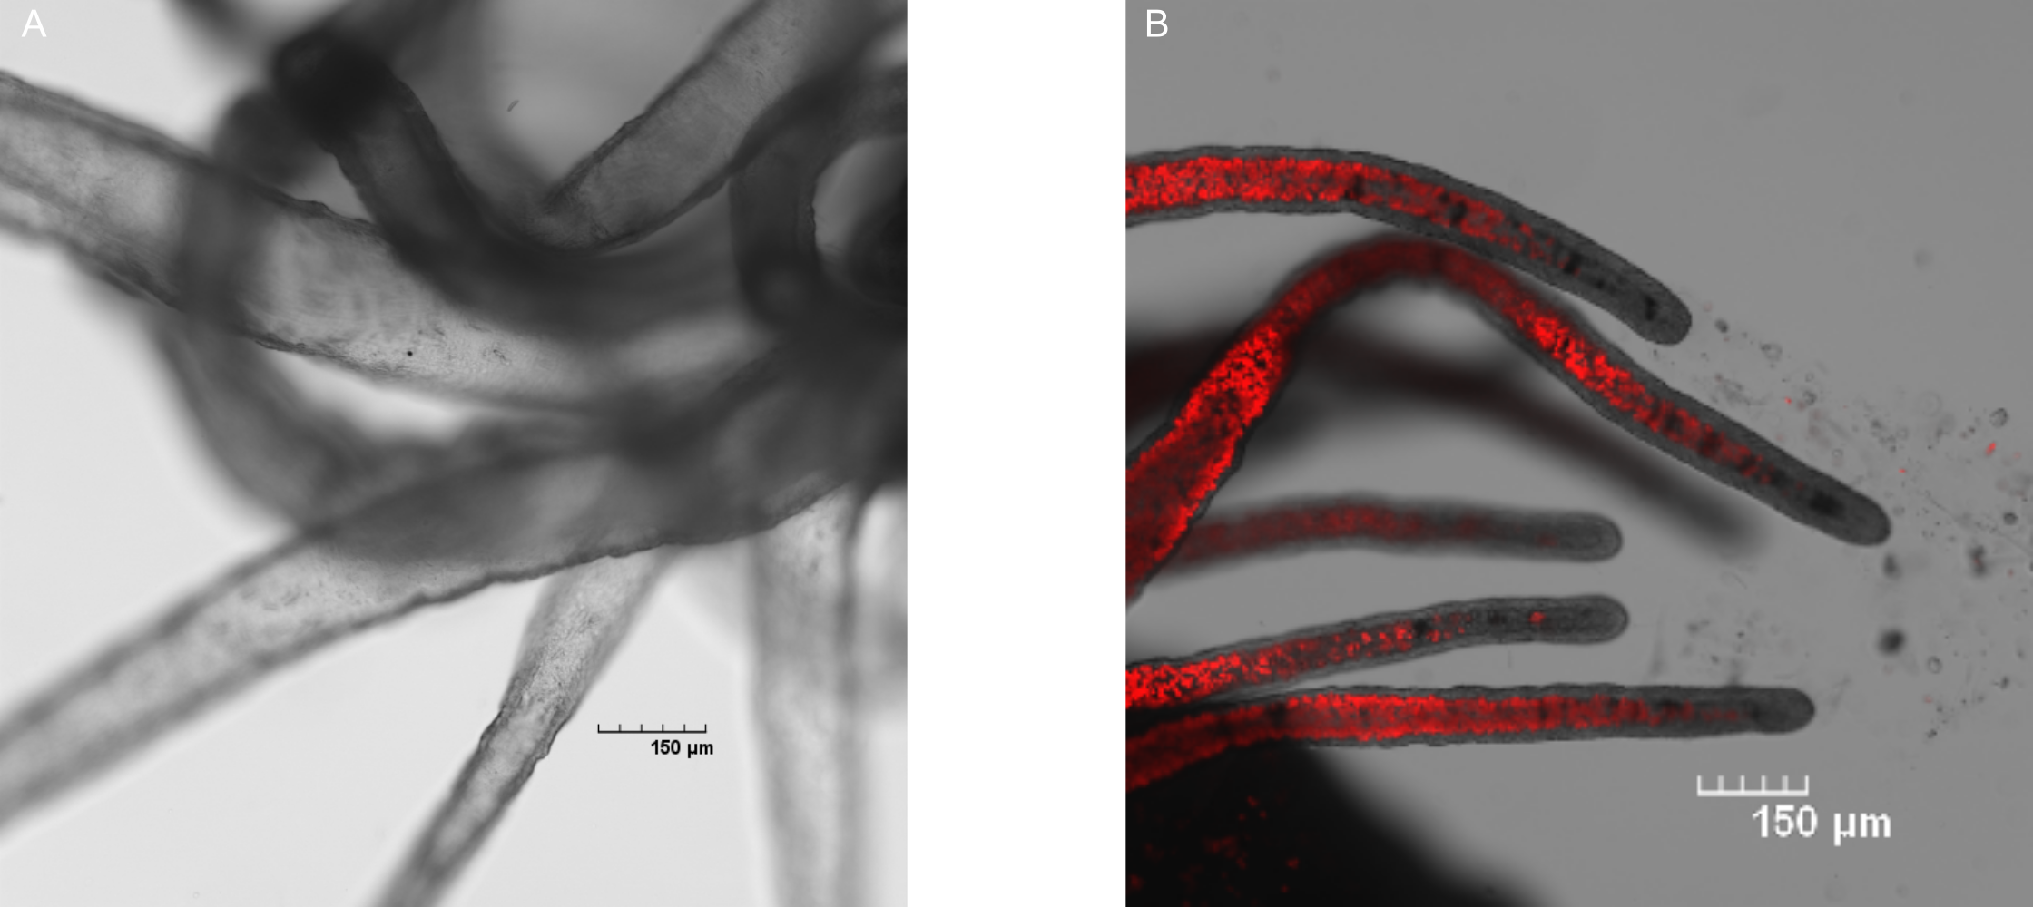

Figure S1. Confocal examination for the presence of symbionts by chlorophyll autofluorescence. A) Aposymbiotic anemone B) Anemone   
hosting *B. minutum* symbionts. Red, chlorophyll autofluorescence of the symbionts.

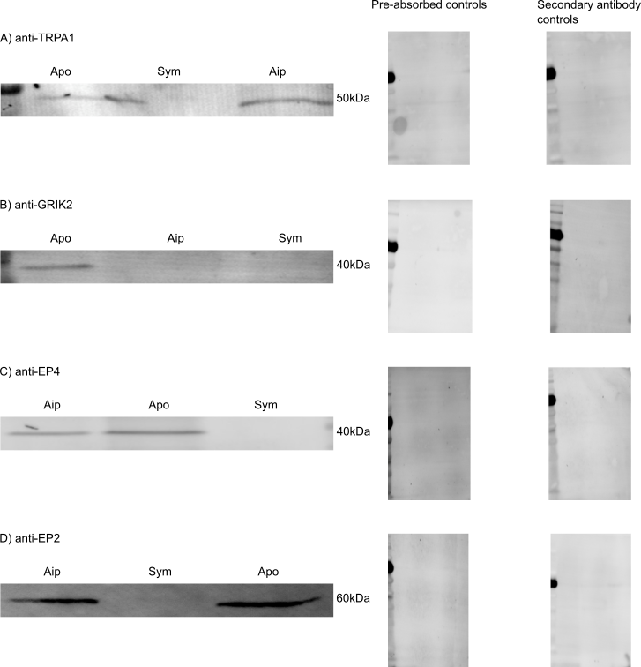

Figure S2. Expression of the selected receptors in Aposymbiotic (apo), symbiotic (Aip) anemones and cultured symbionts as controls. Pre absorbed controls 2x concentration of the antigen and secondary antibody controls (controls and secondary antibody (Goat Anti Rabbit IgG AlexaFluor®555) controls are also shown). A) TRPA1 50 kDa, B) GRIK2 40 kDa, C) EP4 40 kDa, D) EP2 60 kDa.

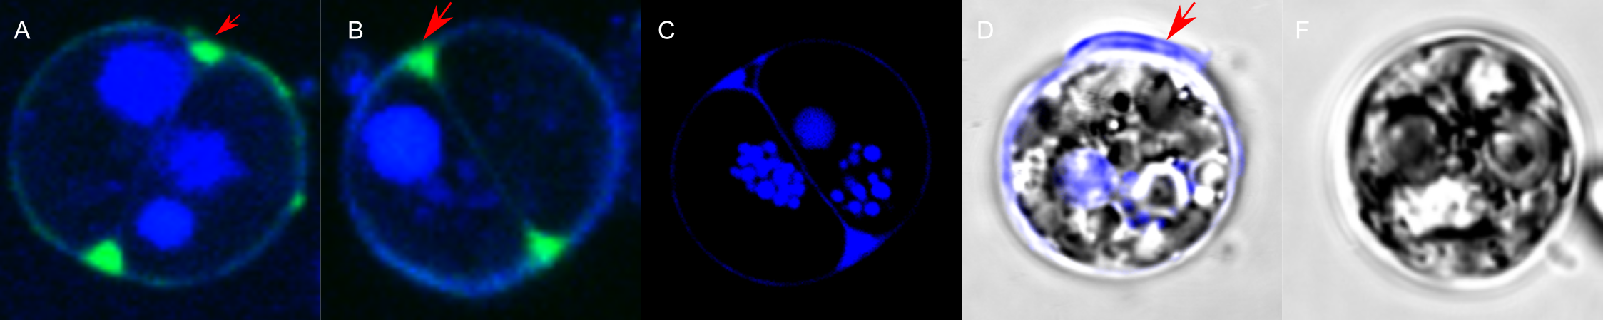

Figure S3. Confocal verification of the presence of the symbiosome membrane and the absence of the host nucleus using FM 1-43 stain. A + B) Dividing symbionts with the absence of host nucleus and with the symbiosome starching between the two indicated by the red arrows. C) Example of diving symbionts with the absence of the host nucleus. D) Symbiont with the presence of the host nucleus indicated by the red arrow. F) Control consisting in a cultured symbiont stained with FM 1-43. Blue, nuclear staining using DAPI; green, membrane staining using FM 1-43

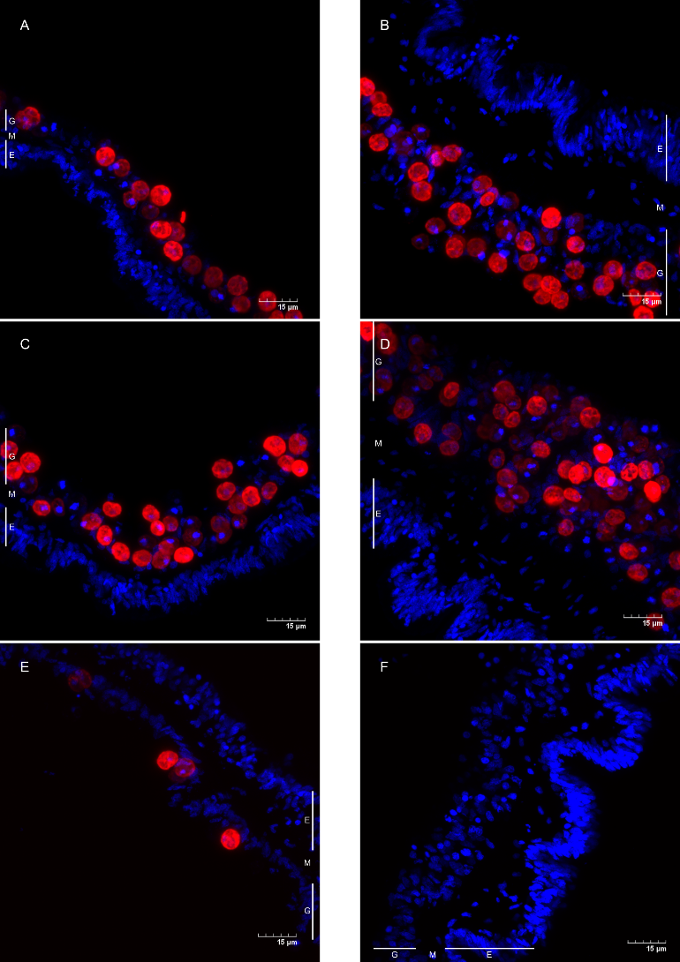

Figure S4. Immunolocalization controls consisting in antigen pre absorption of A) anti-TRPA1 B) anti-GRIK2 C) anti-EP2 D) anti-EP4 and secondary antibody controls of symbiotic (E) and aposymbiotic (F) anemones. Red, chlorophyll autofluorescence of the symbionts; Blue, nuclear staining using DAPI. G = gastrofermis; M = mesoglea, E = epidermis.

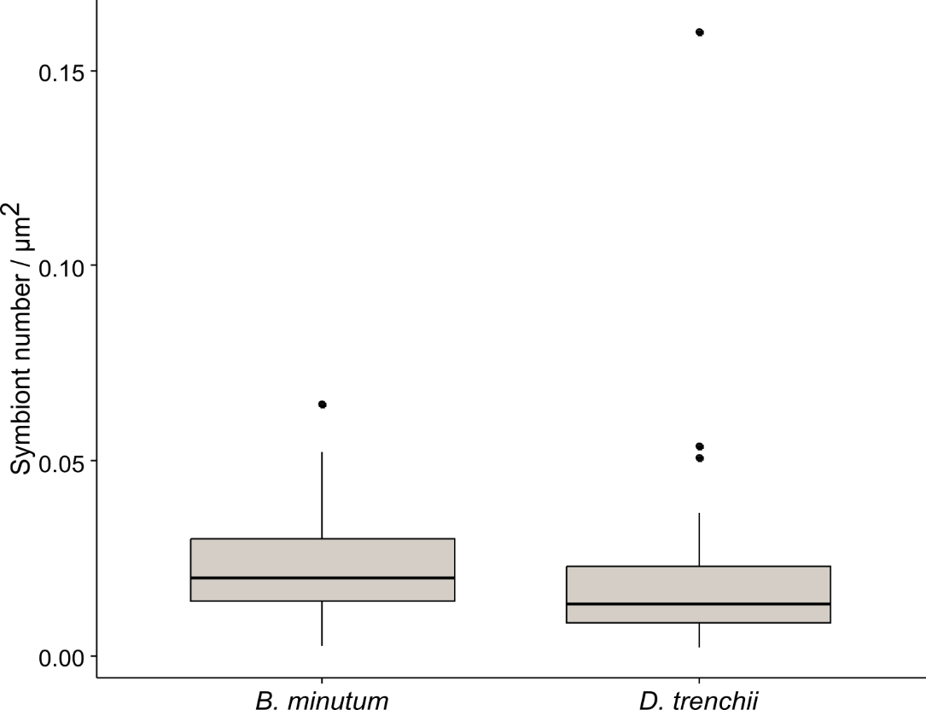

Figure S5. Symbiont density in anemones long term colonized with either *B. minutum* or *D. trenchii* (N = 58)

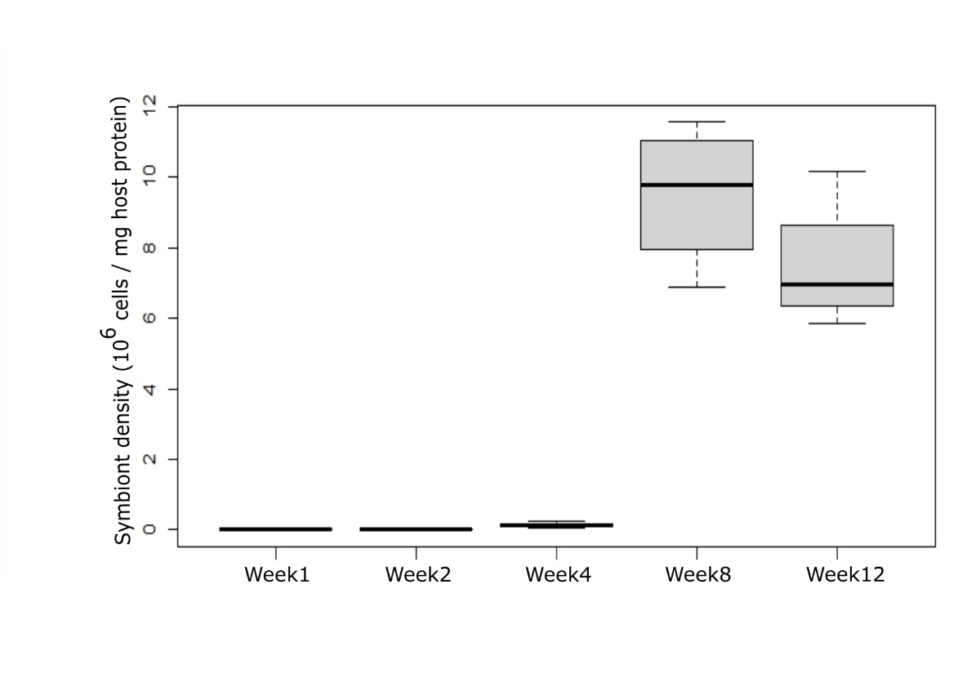

Figure S6. Symbiont density in anemones following the three months post inoculation with *B.minutum* (N= 4)

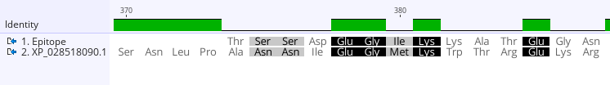Figure S7. Alignment between the protein XP_028518090.1 and the epitope of anti-GRIK2.